

**Draft (May 2021)**

**International Water Management Institute**

**New Delhi**

Drought Proofing Assessment:

Jhalarapatan watershed, Jhalwar district, Rajasthan

Contents

1 Jhalarapatan watershed 3

1.1 Land Use & Soil 4

1.2 Cropping pattern 5

1.3 Irrigation & Domestic 5

2 Drought risk assessment 6

3 Drought proofing assessment 8

4 Application of drought proofing tool 10

4.1 Baseline scenario 11

4.1.1 Water balance 11

4.1.2 Crop water requirement and irrigation water requirement 11

4.1.3 Crop water requirement met and crop yield 12

4.1.4 Drought proofing and Quadrant 13

5 Plan water management interventions 15

5.1 Water management interventions scenarios 17

5.2 Interventions impact on mild drought 18

5.3 Interventions impact on moderate drought 22

5 Cost and benefit analysis 26

6 Conclusion and recommendation 27

Appendix A: Input data 29

# **Jhalarapatan watershed**

Jhalarapatan watershed is located in the Jhalarapatan Block of Jhalawar District in Rajasthan, India (Figure 1a). The Watershed is part of the Chambal basin. The total area of the watershed is 7663 ha. The study area has a Tropical Savanna climatebordering on a hot semi-Arid climateunder Koppen climate classification. South-West monsoon covers most of the annual precipitation. The average annual rainfall is 933.7 mm (1980-2017), of which more than 90% is concentrated in the four monsoon months of June to September (Figure 1b). Also, rainfall is associated with high inter-year variability (Pai et al., 2014). The average annual mean temperature is 25.7 ᵒC with minimum temperature observed in January with a mean of 17.2 ᵒC and maximum temperature is observed in May with a mean of 33.9 ᵒC (Srivastava et al., 2009).

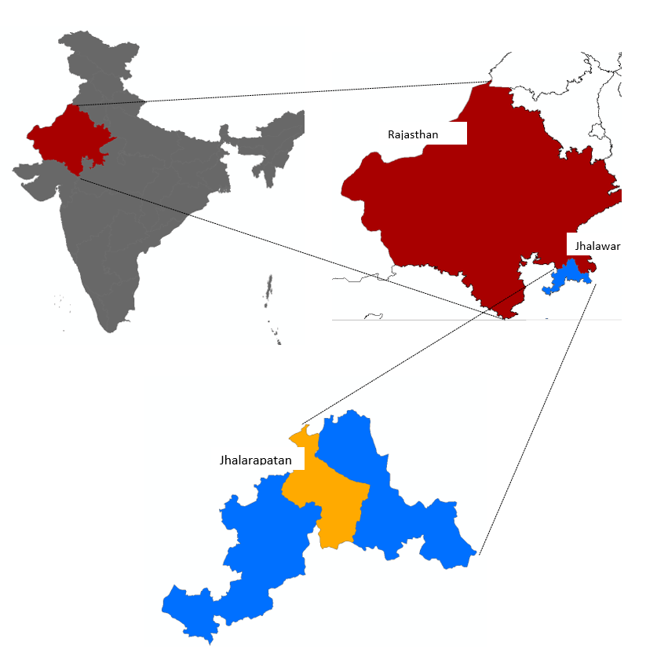

**a**

**b**

Figure 1 a) Study area map and b) Mean monthly rainfall and temperature of Jhalarapatan

## **Land Use & Soil**

Watershed is predominantly cultivated with agricultural area occupying ~ 70 % of the watershed area (Table 1). Forest makes up ~ 15 % of the watershed area. Clay loam is the predominant soil type in the area covering 86 % of the area whereas the rest is covered by loam soil.

Table 1: Land use details of Jhalarapatan

|  |  |  |
| --- | --- | --- |
| S.no | Description | Area (ha) |
| Total Agri catchment Area (ha) | | 7663.3 |
|  | Agriculture Area (Net cultivated sown area) | 5417.7 |
|  | Fallow | 338.7 |
|  | Built-up / Settlements | 370.9 |
|  | Waterbodies | 13.0 |
|  | Pasture | 338.0 |
|  | Forest | 1185.0 |
|  | Other | 0 |

## **Cropping pattern**

There are two main cropping seasons in the watershed: Kharif (overlapping monsoon season) and Rabi (post-monsoon season) (**Figure 2**). In the kharif season, major crops grown are Soyabean, Maize, Blackgram, and Groundnut. Other minor crops grown includes sesame. Most of the crops are covered with full or partial irrigation to provide supplemental irrigation.

In the rabi, major crops grown are Wheat, Mustard, Coriander, and Gram. In the summer season, in a small area Green gram is also taken. Rabi crops (post-monsoon season) are completely dependent on irrigation. Availability of irrigation makes cropping intensity high (~ 183 %) in the watershed.

|  |  |  |  |  |  |  |  |  |  |  |  |
| --- | --- | --- | --- | --- | --- | --- | --- | --- | --- | --- | --- |
| **Jun** | **Jul** | **Aug** | **Sep** | **Oct** | **Nov** | **Dec** | **Jan** | **Feb** | **Mar** | **Apr** | **May** |

Kharif (monsoon) season

Rabi (post monsoon) season

Zaid (summer) season

Maize

Soyabean

Blackgram

Groundnut

Wheat

Mustard

Coriander

Gram

Green Gram

**Figure 2: Cropping calendar of watershed**

## **Irrigation & Domestic**

Of the total gross cropped area, 91 % is partially or fully equipped with irrigation. Groundwater is the main source of irrigation in the district covering more than 95% of irrigated area. High cropping intensity with a large reliance on groundwater has led to overexploitation of groundwater. Groundwater in the Jhalwar district and Jhalrapatan block classified as overexploited with the stage of extraction (total abstraction/total recharge) at 120 % and 125 %, respectively (CGWB, 2013).

Groundwater in the watershed is found at shallow depths under unconfined conditions in aquifer characterized by Basalt of Deccan traps (CGWB, 2013). Deccan trap basalt has highly upper weathered parts to a depth of 20-30 m, which is mostly tapped by large-diameter dug wells, to create large storages through slow seepage, for irrigation (Minor irrigation census, 2013-14). This is underlain by consolidated basalt rocks where groundwater is present in fractured and vesicular zones in successive basalt flows tapped by bore wells (Patel et al., 2020). Dug wells are predominantly used in the watershed and the yield of open wells ranges from a few to 330 m3 /day. Groundwater well yields as in other hard rock regions are seasonally dependent and highest after monsoonal recharge (Pavelic et al., 2012). The mean groundwater depth varies from 8-16 meters below ground level (mbgl) in pre-monsoon to 5-12 mbgl in post-monsoon season (CGWB, 2013).

# **Drought risk assessment**

For assessing ITC agri-catchments, the widely used rainfall index “*Standard Precipitation Index” (SPI) (*World Bank, 2019; Sönmez et al., 2005) is used. SPI is calculated by taking the difference of the precipitation from the mean for a particular time step, and then dividing it by the standard deviation and is based on the long-term precipitation data (Sönmez et al., 2005). For SPI, only rainfall data is needed which is the primary causative factor of drought thus making SPI easy to calculate.



SPI is a dimensionless index where negative values indicate drought and positive values wet conditions with the range of SPI values can be categorized across different drought intensities (Table 2).

Table 2: SPI values-based drought categories

|  |  |
| --- | --- |
| **SPI values** | **Drought category** |
| **0 to -0.99** | Mild drought |
| **-1.00 to -1.49** | Moderate drought |
| **-1.50 to -1.99** | Severe drought |
| **< -2.0** | Extreme drought |

SPI is calculated based on monthly rainfall data of the last 20 years (1998-2017). To segregate seasonal and annual drought, drought frequency for the annual, kharif, and rabi season is calculated separately. Shorter periods (seasonal droughts) are important to assess agricultural droughts whereas longer/annual droughts are used to assess hydrological droughts. Based on assessed drought, both seasonal and annual, effectively planning and designing of interventions to mitigate drought can be done.

For each season and annually, % of years under different drought categories is calculated (**Table 3**). Results show that mild drought is the most occurring drought in the regions occurring every third year. After that, moderate drought has the highest frequency of occurring relatively more in kharif season. The occurrence of severe and extreme drought in the region is limited. Annual time series of rainfall with drought category (Figure 3) shows that of last 15 years, 10 years have been either mild or moderate drought year. This suggests that drought proofing activities should actively focus on cover mild and moderate droughts.

**Table 3:** **Drought intensity and their frequency for different periods.** The percentage indicates the percent of total assessed years classified under different drought categories.

|  |  |  |  |
| --- | --- | --- | --- |
|  | **Kharif (Jun-Sep)** | **Rabi (Oct-Jan)** | **Annual** |
| **No drought** | 50% | 55% | 55% |
| **Mild drought** | 32% | 37% | 39% |
| **Moderate drought** | 13% | 5% | 0% |
| **Severe drought** | 3% | 5% | 5% |
| **Extreme drought** | 3% | 0% | 5% |

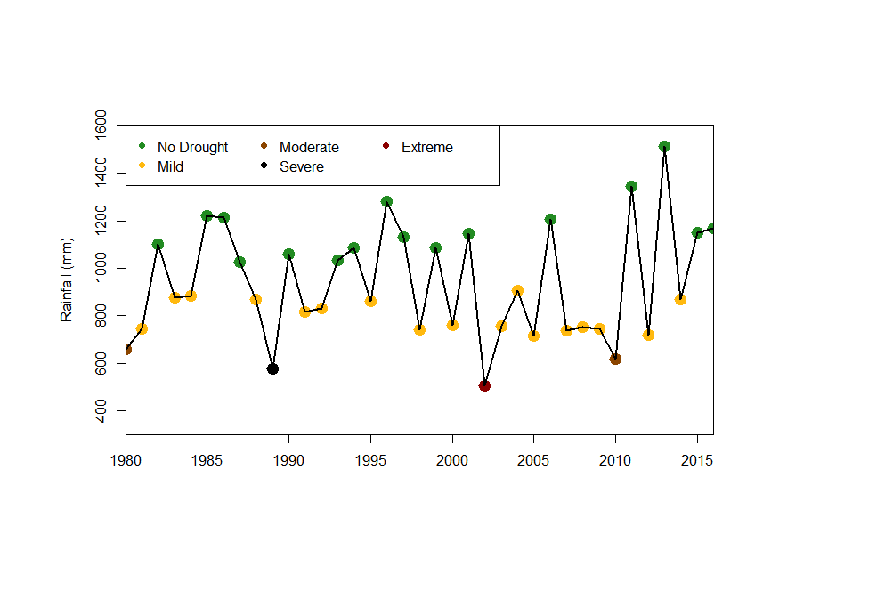

Figure 3: Annual time series of rainfall with drought category

# **Drought proofing assessment**

Drought proofing assessment is carried out using the developed conceptual drought proofing framework (**Figure 4**). In the framework, Drought proofing in a watershed is conceptualized as an interaction between water availability for crops and water use efficiency (Figure 4). At the base level, drought proofing is defined as an interaction between water availability for a crop (mm or m3 ha-1 or % of crop water needs met) and water use efficiency (Figure 4). Water availability for a crop is the water available from all the sources (rainfall, soil moisture, groundwater, and surface water storage) to meet crop water requirements. Water efficiency determines how efficiently irrigation water is used. For irrigated areas, this is the irrigation application efficiency. For rainfed areas, this can be translated to how efficiently rainfall is used.

Across a simple 2*2 plane, we can identify four distinct quadrants (**Figure 4**) with water availability for a crop on the y-axis and crop water use efficiency (WUE) on x-axis. Based on the analysis and where watershed crops lie in different rainfall years, users can identify the type and intensity of required interventions. Water availability can be increased with supply augmenting practices (storage, recharge, and soil moisture conservation) whereas water use efficiency can be increased through water saving and irrigation application efficiency measures (micro-irrigation).

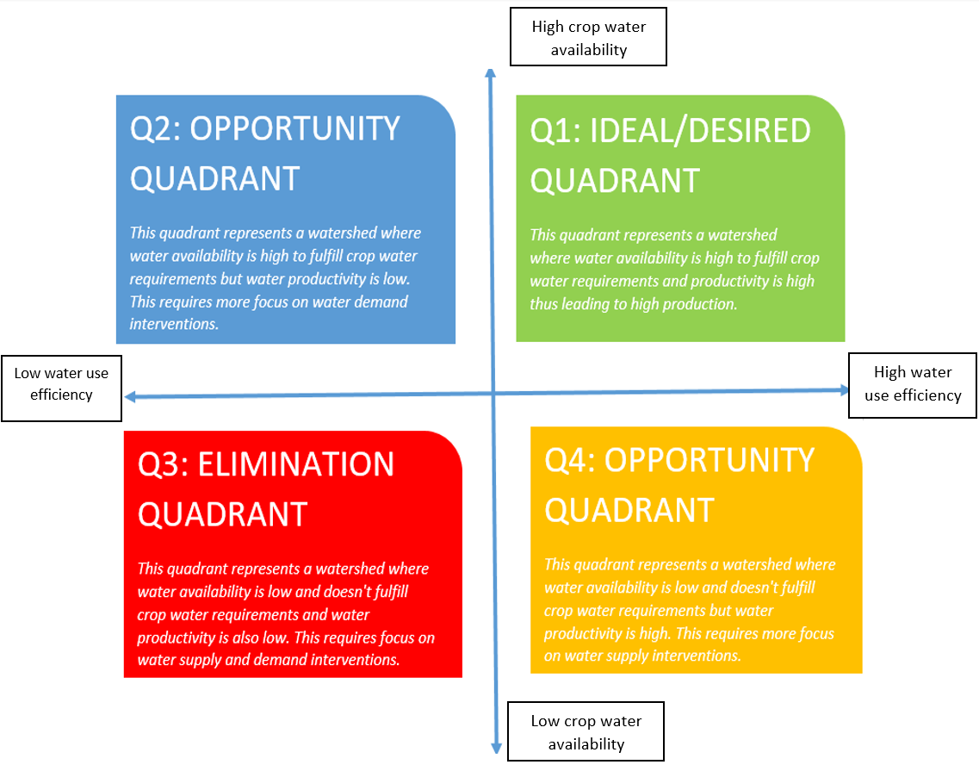

**Figure 4: Conceptual physical drought proofing framework**

With water as the key input to the drought-proofing framework (**Figure 4**), water balance tool is developed to operationalize the framework. The tool is modeled in excel spreadsheet with minimum input data requirements for simplifications. Drought Proofing Tool is developed in MS Excel + Visual Basic Editor (VBA) platform.

The water balance tool helps in site-specific water balance, crop yield, and crop requirement assessments. The two-key function of the tool is as follows:

* To assess the water balance of the study area for various hydrological conditions (dry, normal & wet years)
* To assess the impact of proposed water management interventions in achieving drought proofing

Here we provide the results of the application of the water balance tool for the watershed. For details on the methodological and workflow of the tool, please check Technical Manual, User Manual, and Case Study example.

# **Application of water balance tool**

The first step is the entry of input data. Input data to tool covers: Land use and soil data, crop details, irrigation and domestic and rainfall and temperature (see user manual). While a brief of each is provided in the study area description and summarised in Table 4, and detailed input data is given in Appendix A.

**Table 4:** **Overview of input data.** Detailed input data is given in Appendix A

|  |  |
| --- | --- |
| Parameter | Information |
| Land use | Table 1 |
| Soil | Clay loam (85 %) and loam (15 %) |
| Crops | Kharif: Soyabean, Maize and gram |
| Rabi: Wheat and mustard |
| Zaid: Gram |
| Irrigation | Crop wise irrigated area, Groundwater irrigation 95 %, default irrigation efficiency of 0.5 |
| Rainfall and temperature | Daily rainfall, mean, max and min temperature data (20 years) |

The flow diagram (**Figure 5**) below gives the step of running the tool and planning water management interventions.

* Step1: Input data is entered in the tool. See Appendix A and the user manual.
* Step 2: Baseline scenario is simulated. Baseline scenario is where no water management interventions are in place.
* Step 3: Water balance, crop water requirements, and crop water deficit results are analyzed
* Step 4: Based on analyzed results, water management interventions are planned and entered in the tool as scenarios
* Step 5: Scenarios are simulated and their impact on drought proofing is analyzed. If drought proofing is not realized, step 3 and 4 are repeated until the best results on drought-proofing are obtained.

Accordingly, results in the upcoming section are given in the same order. As mild and moderate droughts are most frequent, drought proofing assessment is carried out for the same.

**Figure 5: Conceptual workflow of applying drought proofing tool**

### **Baseline scenario**

### **Water balance**

**Table** 5 gives the water balance results for the watershed for the normal, mild and moderate drought years. Normal years include all years where rainfall is above the drought threshold, including wet years. The rainfall in mild and moderate years is lesser by 36 % and 45 % relative to normal years.

In normal years, both runoff (33 % of rainfall) and recharge (15 % of rainfall) are very high. This shows that more than 1/3 of rainfall leaves the watershed as runoff. Both runoff and recharge are relatively lower in mild and moderate years. In mild years, runoff is 20 % and recharge is 9.5 % of rainfall. However absolute runoff is still high (154 mm) showing the potential to capture part of it in surface and groundwater storages. However, in moderate years low rainfall means that both runoff and recharge are small and only ~ 8 % of rainfall. This shows that there is limited potential to capture runoff to increase storage in moderate drought years.

Table 5: Water balance results (in mm)

|  |  |  |  |  |
| --- | --- | --- | --- | --- |
| **Year** | **Rainfall** | **Runoff** | **recharge** | **ET** |
| Normal | 1157.7 | 384.3 | 173.2 | 600.1 |
| Mild | 741.1 | 154.9 | 70.2 | 516.0 |
| Moderate | 622.8 | 52.9 | 51.0 | 518.9 |

### **Crop water requirement and irrigation water requirement**

Table 6 gives the crop water requirement (CWR) and irrigation water requirement (IWR) of each simulated crop for normal, mild, and moderate drought years. CWR of the crop is calculated based on reference evapotranspiration (ET). As there is a slight temperature difference between drought years, CWR differs.

Highest CWR (527.5 mm) is for pulse which is grown in the summer season when ET is high followed by wheat (432.4 mm) and maize (420.1 mm). For other rabi crops of mustard (259.9 mm) and coriander (275.7 mm), CWR is relatively low. Irrigation water requirement (IWR) is the difference between CWR and rainfall in the crop growing period. Thus, in most cases, IWR is higher for drought years when rainfall is lower. Similarly, as the rainfall is concentrated in the monsoon season, IWR for kharif crops is much less relative to rabi crops. For rabi crops, more than 50 % of CWR requires irrigation. For summer pulse, more than 80 % of CWR required irrigation. Highest IWR is for summer pulse (> 400 mm) and wheat (226-255 mm) followed by coriander and maize. IWR of kharif crops is much lower but increases in mild and moderate drought years.

Table 6: CWR & IWR of the crops in the watershed (in mm)

|  |  |  |  |  |  |  |  |
| --- | --- | --- | --- | --- | --- | --- | --- |
| Season | Crop | Normal | | Mild | | Moderate | |
| **CWR** | **IWR** | **CWR** | **IWR** | **CWR** | **IWR** |
| Kharif | **Soyabean** | 382.2 | 47.1 | 381.7 | 85.3 | 396.8 | 89.6 |
| **Maize** | 420.1 | 52.0 | 417.1 | 57.5 | 431.5 | 68.7 |
| **Pulse** | 349.9 | 27.8 | 350 | 29.8 | 363.4 | 34.5 |
| Rabi | **Wheat** | 432.4 | 251.1 | 426.4 | 255.2 | 424.5 | 226.5 |
| **Mustard** | 259.9 | 164.3 | 256.2 | 152.0 | 253 | 151.4 |
| **Coriander** | 275.7 | 205.7 | 271.6 | 210.2 | 267.1 | 186.3 |
| Summer | **Pulses** | 527.5 | 484.3 | 528.2 | 495.1 | 553.7 | 545.0 |

### **Crop water requirement met and crop yield**

CWR is met by rainfall and soil moisture in the case of rainfed crops whereas irrigated areas can also access irrigation storage to meet CWR. For this reason, CWR met (% of CWR needs to be fulfilled) of the irrigated crop is higher than the rainfed crops (Table 7).

Results show that for normal years, most of CWR is met for Kharif (~ 90 %) and Rabi crops ( ~ 85 %). This is expected in normal years as rainfall is high meaning low IWR, and recharge is also high to provide irrigation to rabi crops. For kharif crops, the impact of both mild and moderate drought on the crop is limited due to the concentration of rainfall during the monsoon season, hence CWR is mostly met. CWR met for the irrigated crops is ~ 90 % whereas there is a slight decrease in CWR met for rainfed areas ranging from 77-90 %. However, as most of the kharif area is supplemented with irrigation (Appendix A, Table 1b) the impact of drought remains limited.

However, this is not the case for rabi season. Low rainfall leading to low recharge on which rabi crops rely on means that most of CWR remain unmet. CWR met ranges from 40-53 % for mild drought years and from 42-53 % in moderate drought years. In all cases, CWR met of summer pulse remains low. Even in normal years, only 19 % of CWR can be met which is an indication of high IWR of summer pulse, and also by summer much of groundwater storage is already depleted hence there is no water available to meet the CWR for summer pulse. This shows why a very small area of summer pulse (~ 8.5 ha) is taken which might be supported through deep borewells.

Table 7: Percent of total CWR met for each crop in different drought years

|  |  |  |  |  |  |  |  |
| --- | --- | --- | --- | --- | --- | --- | --- |
| Season | Crop | Normal | | Mild | | Moderate | |
| **Irrigated** | **rainfed** | **Irrigated** | **rainfed** | **Irrigated** | **rainfed** |
| Kharif | Soyabean | 95.1% | 87.8% | 89.0% | 77.7% | 86.4% | 77.4% |
| Maize | 95.0% | 87.8% | 92.3% | 86.2% | 87.7% | 84.1% |
| Pulse | 95.8% | 92.2% | 94.9% | 91.5% | 92.3% | 90.5% |
| Rabi | Wheat | 84.5% | - | 50.7% | - | 52.4% | - |
| Mustard | 88.9% | - | 52.9% | - | 49.9% | - |
| Coriander | 85.1% | - | 40.2% | - | 42.0% | - |
| Summer | Pulses | 19.4% | - | 8.9% | - | 1.6% | - |

Crop yield (as % of attainable yield) is influenced by how much CWR is met (Table 7) and how sensitive it is to water deficits (Steduto et al., 2012). Crop yields (Table 8) follow the same trend as CWR met inTable 7. The crop yield of rabi crop is significantly impacted in drought years. This shows that interventions should primarily focus on increasing the CWR met for rabi crops.

Table 8: Crop yield (as % of attainable yield) in different drought years

|  |  |  |  |  |  |  |  |
| --- | --- | --- | --- | --- | --- | --- | --- |
| Season | Crop | Normal | | Mild | | Moderate | |
| **Irrigated** | **rainfed** | **Irrigated** | **rainfed** | **Irrigated** | **rainfed** |
| Kharif | Soyabean | 95.8% | 89.7% | 90.7% | 81.1% | 88.4% | 80.8% |
| Maize | 93.7% | 84.8% | 90.4% | 82.8% | 84.6% | 80.1% |
| Pulse | 96.7% | 93.8% | 95.9% | 93.2% | 93.9% | 92.4% |
| Rabi | Wheat | 83.0% | - | 45.8% | - | 47.7% | - |
| Mustard | 87.8% | - | 48.1% | - | 44.9% | - |
| Coriander | 86.6% | - | 46.2% | - | 47.8% | - |
| Summer | Pulses | 35.5% | - | 27.1% | - | 21.3% | - |

### **Drought proofing and Quadrant**

Plotting CWR met and irrigation efficiency of the crop on drought proofing quadrant (**Figure 6**) shows which crop and what kind of interventions are needed. As discussed above, it becomes clearer from drought proofing quadrant figures that interventions for kharif crop needs to be focussed on improving efficiency and relatively less on supply as CWR met is already on the higher end. Whereas for rabi crops (wheat & mustard), interventions need to be focussed on both supply and demand to improve both the CWR met and irrigation efficiency.

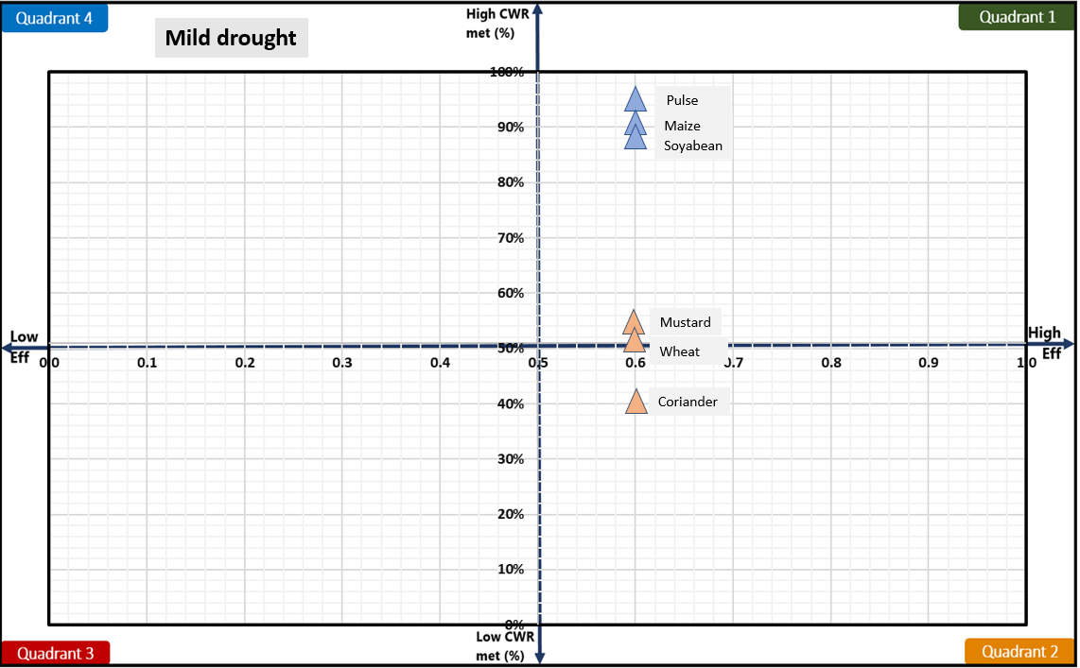

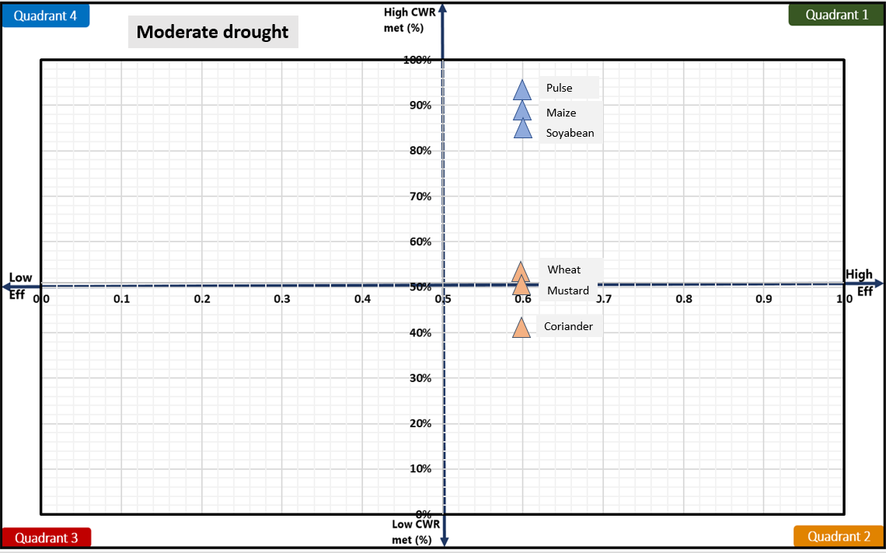

**Figure 6: Drought quadrant for mild (top) and moderate (bottom) drought**

# **Plan water management interventions**

Crop water balance and deficit (CWR met) shows which crops are impacted the most and drought proofing quadrant shows which interventions are needed. However, the intensity or scale of water management interventions should be planned based on how much water is available and absolute crop deficits (in m3). Crop water deficits (CWR – CWR met) can be assessed from results on CWR (Table 6) and CWR met (Table 7). Table 9 gives the crop water deficit (in m3) for all crops for mild and moderate drought years. Crop water deficit (in m3) is derived by multiplying unmet CWR (in mm) to the crop area.

Results show a high absolute water deficit for all the rabi crops. This is driven by low CWR met (%) as given in Table 7. The highest absolute water deficit (in m3) is for wheat followed by other rabi crops of mustard and coriander. Despite a similar percentage of CWR met (Table 7), the highest water deficit in wheat is a result of both its high CWR (Table 6) and high cropping area (Table 1C, Appendix A). This shows the one potential strategy to reduce the overall deficit by shifting crop area from wheat (high CWR, high deficit) to mustard and coriander (low CWR, low deficit).

For the kharif crops, the absolute water deficit is relatively lower. However, soyabean shows a high absolute water deficit. Though more than 80 % of Soyabean is met (Table 7), the large crop area of soyabean means the absolute water deficit (area * unmet CWR) remains high.

Absolute crop water deficit (in m3) can give an idea on the intensity of interventions required. In addition to supply measures, water-saving can be achieved through improving irrigation efficiency measures. Table 9 also gives the potential savings that can be achieved if irrigation efficiency is improved to 0.75 and 0.9 for all crops. Potential savings (in m3) are derived assuming all irrigation water requirement (IWR) is met through increased efficiency. Calculations show that savings from increased irrigation efficiency can potentially cover 40-75 % of absolute crop water deficits.

Table 9: Absolute crop water deficit and potential saving from increasing irrigation efficiency for mild and moderate drought years.

|  |  |  |  |  |  |  |  |
| --- | --- | --- | --- | --- | --- | --- | --- |
| **Season** | **Crop** | **Mild** | | | **Moderate** | | |
| **Deficit (‘000 m3)a** | **Potential savings (‘000 m3)b** | | **Deficit (‘000 m3)** | **Potential savings (‘000 m3)** | |
|  | Eff =0.75 | Eff = 0.9 |  | Eff = 0.75 | Eff = 0.9 |
| **Kharif** | Soyabean | 1208 | 820 | 1366 | 1556 | 861 | 1435 |
| Maize | 213 | 127 | 212 | 353 | 152 | 253 |
| Pulse | 86 | 48 | 81 | 135 | 56 | 93 |
| **Rabi** | Wheat | 3788 | 1534 | 2556 | 3642 | 1361 | 2268 |
| Mustard | 1554 | 652 | 1087 | 1630 | 650 | 1083 |
| Coriander | 1597 | 689 | 1148 | 1523 | 611 | 1018 |
| **Summer** | Pulses | 41 | 14 | 23 | 46 | 15 | 26 |
|  | Total | 8487 | 3884 | 6473 | 8885 | 3706 | 6176 |

a deficit = [CWR*(1-CWRmet(%)]*Crop area

b savings = [(IWR/effc) - (IWR/effim)]*Crop area, where effc and effim is the current and improved irrigation efficiency.

Table 10 compares the total deficit and total potential irrigation savings to available water. Available water is the runoff in the area which can be captured for storage or recharge to meet crop water deficits. Comparison shows that for mild drought years, available water is more than the crop water deficit meaning supply side interventions can potentially mitigate the drought impact. Along with irrigation improving measures, there is potential to completely mitigate the impact of mild drought. However, for moderate drought years, available water is not sufficient to meet the crop water deficit. Drought proofing moderate years potentially will require interventions such as shifting or reducing crop area of high-water consuming crops.

Table 10: Comparison of total available water with total deficit and irrigation potential savings (in m3)

|  |  |  |  |  |  |
| --- | --- | --- | --- | --- | --- |
|  | Available watera | Total deficit | Potential savings [0.75] |  | Potential savings [0.9] |
| Mild | 11870 | 9667 | 3884 |  | 6473 |
| Moderate | 4054 | 9991 | 3706 |  | 6176 |

a runoff*Watershed area

## **Water management interventions scenarios**

Based on the assessed deficit, potential irrigation savings, and available water, the following initial 5 scenarios are designed and simulated (**Table 11**). Scenario 1 to 5 gradually increases the intensity of interventions. Scenarios primarily cover supply and demand-side interventions.

Supply side is proposed to be augmented through storage and recharge from farm ponds, check dams, and infiltration basins. Total created capacity range from 2-12 % and 7-35 % of available water (runoff) for mild and moderate drought years, respectively. For the demand side, sprinkler irrigation for rabi crops (mustard and wheat) is planned. Sprinkler irrigation can improve the efficiency of irrigation to 0.75. Area covered by sprinkler range from 16 % (scenario 1) to 100 % (scenario 5) for wheat and mustard area. In addition, broad bed furrow (BBF) for soyabean is planned to cover 22 % - 100 % of the area under scenarios. BBF can save 15-30 % of water relative to flood irrigation and help in retaining soil moisture (decreasing runoff) and draining excess runoff.

**Table 12** gives input parameters of the interventions added to the model. For details of parameters or step-by-step instructions on how to run scenarios, please see [user manual](https://drive.google.com/drive/folders/1Yi0Qt4JraRVXNljxe3DB_TAdu5VM8bhg).

**Table 11: Water management interventions under different scenarios**

|  |  |  |  |  |  |
| --- | --- | --- | --- | --- | --- |
| Scenario | Supply interventions | | | Demand interventions | |
| Number (#) | | | Area (ha) | |
| Farm pond | Check dam | Infiltration basins | Sprinkler  [wheat and Mustard] | BBF [soyabean] |
| 1 | 100 | 5 | 2 | 500 | 750 |
| 2 | 150 | 10 | 4 | 1000 | 1500 |
| 3 | 200 | 15 | 5 | 1500 | 2500 |
| 4 | 250 | 20 | 6 | 2250 | 3000 |
| 5 | 300 | 25 | 7 | 3000 | 3430 |

**Table 12: Input parameters of water management interventions**

|  |  |  |
| --- | --- | --- |
| Interventions | Impact/technical parameters | Cost, Life span, maintenance, |
| Farm ponds | Storage: 250 m3  Depth: 2.5 m  Infiltration rate: 9 mm day-1 | Cost: 80 INR m-3  Annual maintenance: 0 %  Life span: 10 years |
| Check dam | Storage: 25000 m3  Depth: 2.5 m  Infiltration rate: 9 mm day-1 | Cost: 100 INR m-3  Maintenance: 2 %  Life span: 15 years |
| Infiltration basins | Storage: 75000 m3  Infiltration rate: 50 mm day-1 | Cost: 85 INR m-3  Maintenance: 4 %  Life span: 7 years |
| Sprinkler | Increased efficiency: 0.75 | Cost: 25000 INR ha-1  Maintenance: 10 %  Life span: 10 |
| Broad bed furrow | Runoff reduction: CN by 4  Irrigation water saving: 25 % | Cost: 100 INR ha-1  Maintenance: -  Life span: 1 |

## Interventions impact on mild drought

**Figure 7** shows the impact of interventions on the runoff and recharge in the watershed for mild drought years. With increasing intensity of interventions, runoff is gradually reduced, and recharge is gradually increased. Compared to the baseline scenario with no interventions, runoff is reduced by 45 % (absolute decrease of 71 mm), and recharge increased by 65 % (an absolute increase of 46 mm) in scenario 5. Similarly, the efficiency of wheat and mustard increases from 0.6 (in the baseline) to 0.8 (in scenario 5) and the efficiency of soyabean increases from 0.6 (in the baseline) to 0.72 (in scenario 5).

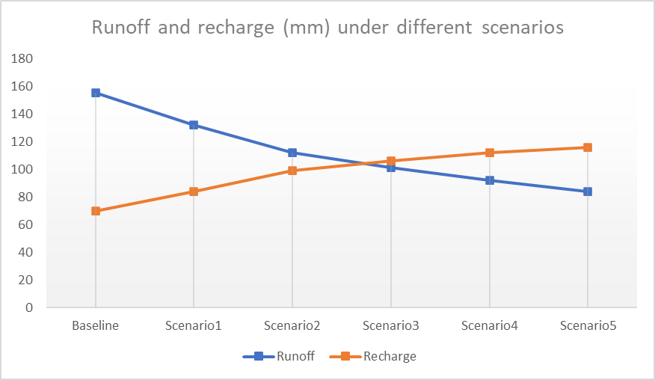

**Figure 7: Impact of interventions on the runoff and recharge in the watershed for mild years**

The impact of increased storage (surface and groundwater) and increased efficiency is visible in increasing yield (shown as % of attainable yield) for different scenarios (Figure 8). Figure 8 shows that kharif crops are mostly drought proofed with their yields above 95 % for all scenarios. Even in baseline scenarios, their yield remains high which reflects that their CWR is mostly met (Table 7).

The main impact of interventions is visible for rabi crops wherein baseline scenarios less than 50 % CWR is met (Table 7). Under the increasing intensity of interventions, the yield (% of attainable yield) of rabi crop increases from ~45 % in the baseline scenario to ~ 75 % in scenario 5. However, even after scenario 5, their yield remains below 80 % of attainable yield reflecting additional interventions are required to make them drought proofed (defined here as when yield is more than 80 % of attainable yield).

For that, an additional **Scenario 6** is planned and added. **Scenario 6** entails:

* Increasing supply augmentation measures. As sufficient runoff is available after scenario 5 (**Figure 7**), further storage interventions are added. This includes additional 50 farm ponds, 5 check dams, and 1 infiltration basin.
* Irrigation efficiency measure is expanded to coriander irrigation. Drip irrigation is planned on 500 ha of coriander area.
* Additionally, a slight change in crop area from high CWR crop wheat to low CWR mustard (Table 6) is planned. Under this 500 ha of wheat area is reduced and converted to the mustard area.

The impact of these additional interventions (Scenario 6) is visible in **Figure 8**. Yield of rabi crops increases from ~ 75 % under scenario 5 to ~ 85 % in scenario 6. However, despite all the interventions summer crop of pulse remains vulnerable to drought despite showing a significant improvement over baseline. Summer pulse yield increases from 27 % in the baseline scenario to 60 % in scenario 6. The area of summer pulse is very small and current scenarios suggest that there is very limited possibility to increase or support summer pulse.

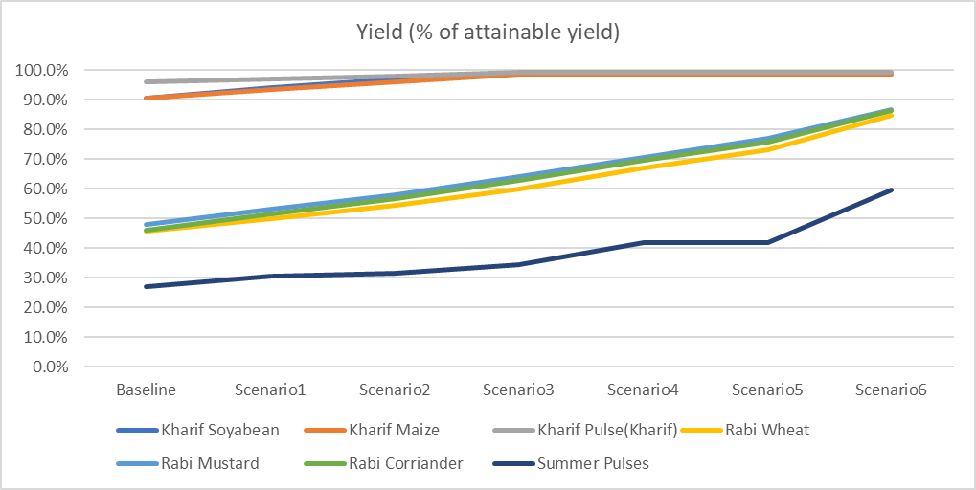

**Figure 8: Crop yield (% of attainable yield) under different scenarios for mild years**

*For crops with both rainfed and irrigated areas, area-weighted yield is shown.

**Figure 9** shows the impact of interventions on drought-proofing quadrant. Increased CWR met and increased efficiency is visible for all crops with crops moving further towards the right top corner in quadrant 1 (desirable quadrant). Maize and pulse (kharif) only move in upward direction as irrigation efficiency measures were implemented for the crops.

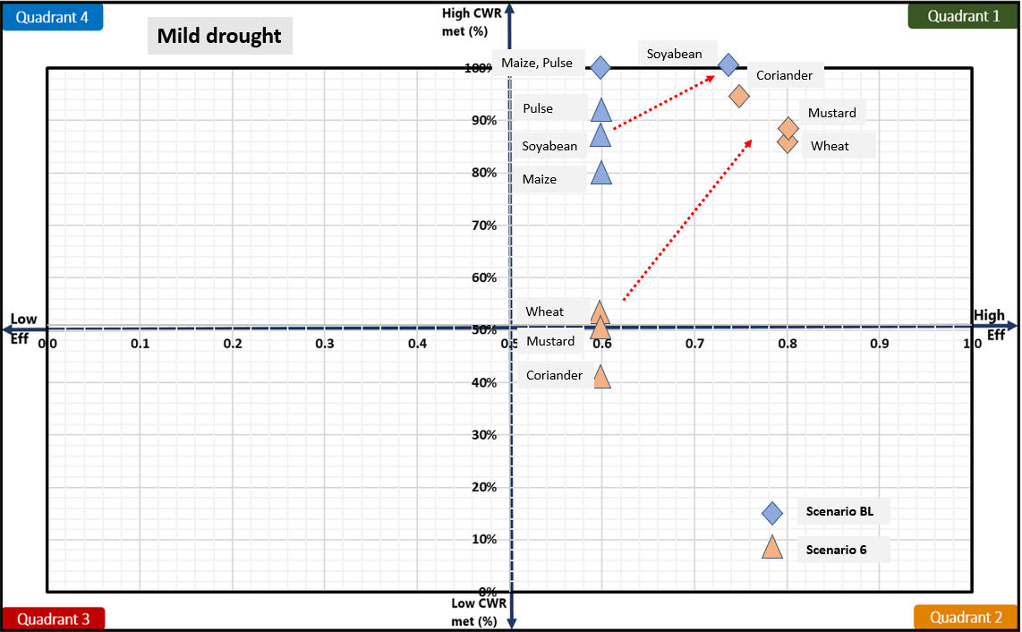

**Figure 9: Impact of interventions visualised on drought proofing quadrant**

**Figure 10** shows the overall watershed drought proofing result for mild years. Percent drought proofing represents total crop production of the watershed as a percent of total potential crop production (i.e. production without any water stress) under different scenarios. The plot shows that drought-proofing is achieved in scenario 6 where drought proofing is almost 90 %. This means that under mild drought if scenario 6 is planned, 90 % of potential production can still be achieved despite the drought.

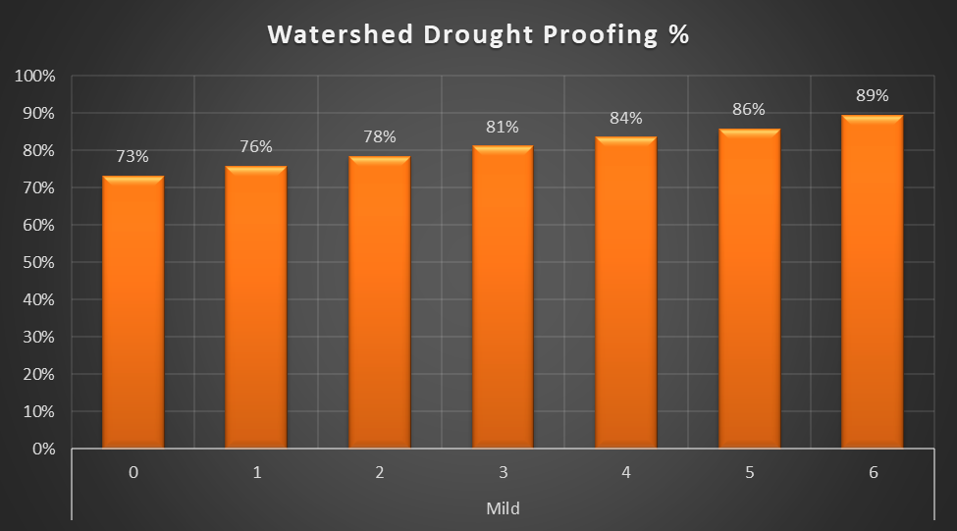

**Figure 10: Overall watershed drought proofing percentage under different scenarios for mild years**

## **Interventions impact on moderate drought**

**Figure 11** shows the impact of interventions on the runoff and recharge in the watershed for moderate drought years. With increasing intensity of interventions, runoff is gradually reduced, and recharge is gradually increased. Compared to the baseline scenario with no intervention, runoff is reduced by 75 % (absolute decrease of 40 mm), and recharge is increased by 43 % (an absolute increase of 22 mm) in scenario 5. Similarly, the efficiency of wheat and mustard increases from 0.6 (in the baseline) to 0.8 (in scenario 5) and the efficiency of soyabean increases from 0.6 (in the baseline) to 0.72 (in scenario 5).

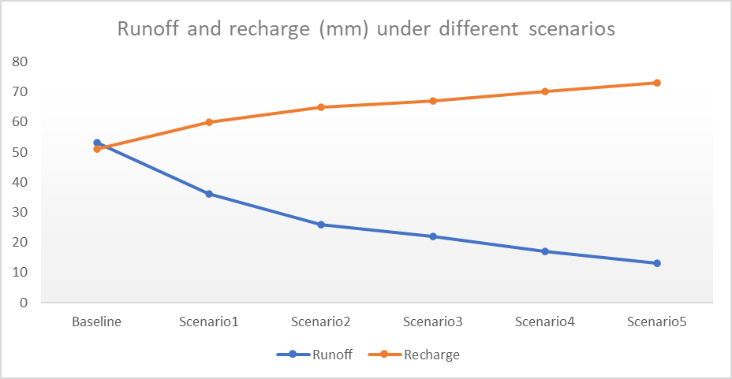

**Figure 11: Impact of interventions on the runoff and recharge in the watershed under different scenarios for mild years**

The impact of increased storage (surface and groundwater) and increased efficiency is visible in increasing yield (shown as % of attainable yield) for different scenarios (Figure 12). Figure 12 shows that kharif crops are mostly drought proofed with their yields above 90 % for all scenarios. Even in baseline scenarios, their yield remains high, though slightly lower than mild years, which reflects that their CWR is mostly met (Table 7).

The main impact of interventions is visible for rabi crops wherein baseline less than 50 % CWR is met (Table 7). However, under the increasing intensity of interventions, yield (% of attainable yield) of rabi crop increases from ~45 % in baseline scenario to only ~ 52-55 % in scenario 5. This contrasts with mild years where yield increases up to ~ 75 % in scenario 5. This is due to limited irrigation storage in moderate years. An increase in storage through a reduction in runoff and increase in recharge is limited in moderate years due to very low runoff. Thus, the benefits of supply augmenting interventions are limited, and thus demand interventions for which irrigation storage is needed also show limited impact in moderate years.

Thus, additional interventions will be required to make them drought proofed (defined here as when yield is more than 80 % of attainable yield). For that, an additional **Scenario 7** is planned and added. **Scenario** 7 entails:

* As there is little runoff left, no more supply measures will work.
* Focusing should be on demand management.
* **Irrigation budgeting**: As kharif crops are drought proofed to an extent, there is a need to reduce irrigation water use in kharif season to save water for rabi season. Reduce irrigation in kharif area (1000 ha for soyabean, 500 ha for maize and all pulse under rainfed).
* **Shifting crops**: In the Rabi season, reducing wheat (high CWR) area by 1000 ha and converting it to mustard (low CWR).
* **Irrigation efficiency**: Converting all the coriander area with drip irrigation.

The impact of these additional interventions (Scenario 7) is visible in **Figure 11**. The yield of rabi crops increases from ~ 55 % under scenario 5 to ~ 85-90 % in scenario 7. However, there is a slight dip in kharif area yield (2-5 %) resulting from converting Kharif irrigated area to rabi area. But the dip is small and the increase in rabi yield (~ 30 %) is much more significant. This shows the potential of smart and effective demand management which is more than implementing sole interventions of irrigation efficiency measures.

However, despite all the interventions summer crop of pulse remains vulnerable to drought despite showing a significant improvement over baseline. Summer pulse yield increases from 21 % in the baseline scenario to 35 % in scenario 7. The area of summer pulse is very small and current scenarios suggest that there is very limited possibility to increase or support summer pulse.

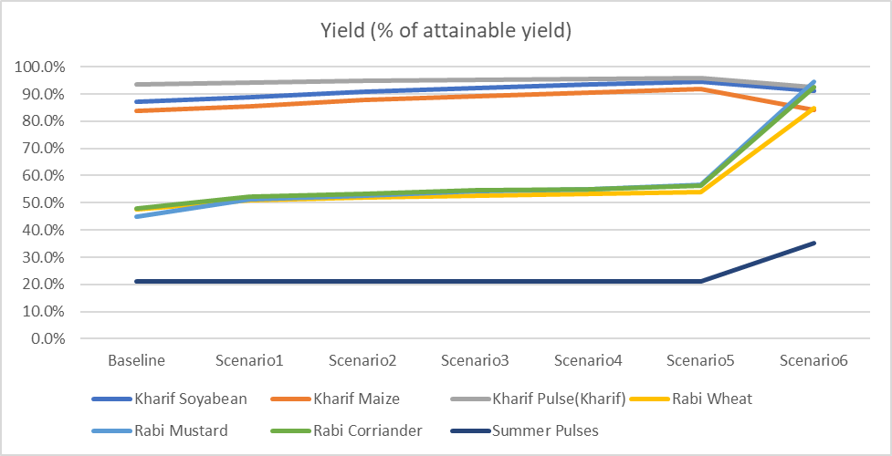

**Figure 12: Crop yield (% of attainable yield) under different scenarios for mild years**

*For crop with both rainfed and irrigated areas, area weighted yield is shown.

**Figure 13** shows the impact of interventions on drought proofing quadrant. Increased CWR met and increased efficiency is visible for all crops with crops moving further towards the right top corner in quadrant 1 (desirable quadrant). Maize and pulse (kharif) only move in upward direction as irrigation efficiency measures were implemented for the crops.

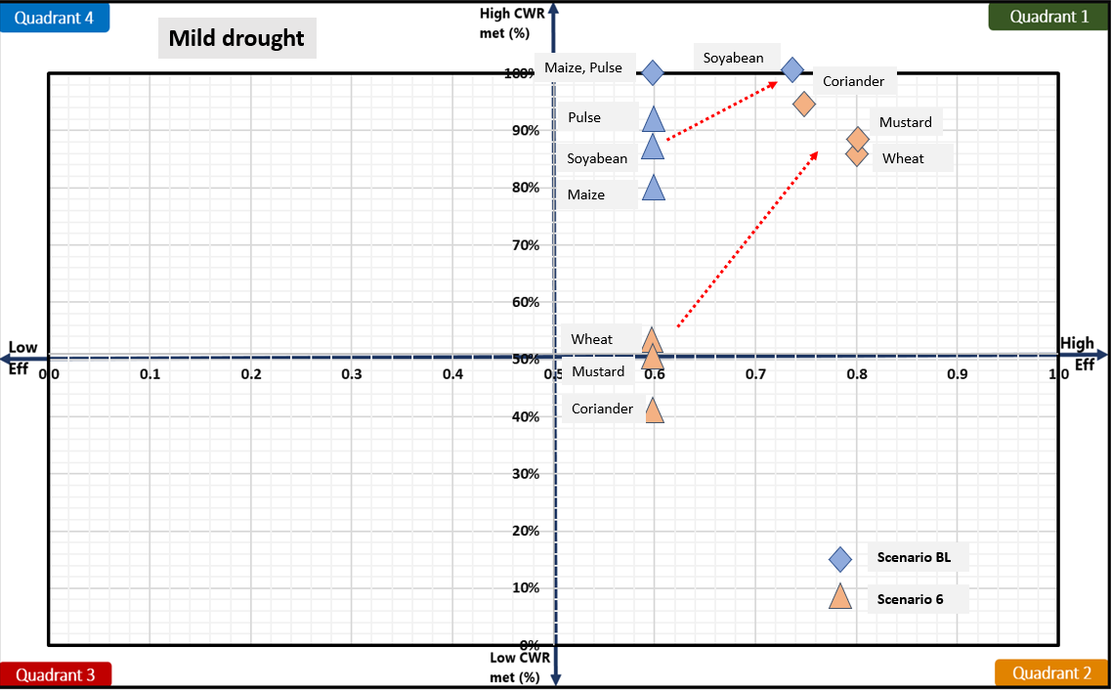

**Figure 13: Impact of interventions visualised on drought proofing quadrant**

**Figure 14** shows the overall watershed drought proofing result for mild years. Percent drought proofing represents total crop production of the watershed as a percent of total potential crop production (i.e. production without any water stress) under different scenarios. Plot show overall drought proofing is gradually increasing with the intensity of interventions and is achieved in scenario 7 with drought-proofing of almost 90 %. This means that under moderate drought if scenario 7 is planned, 90 % of potential production can still be achieved despite the drought.

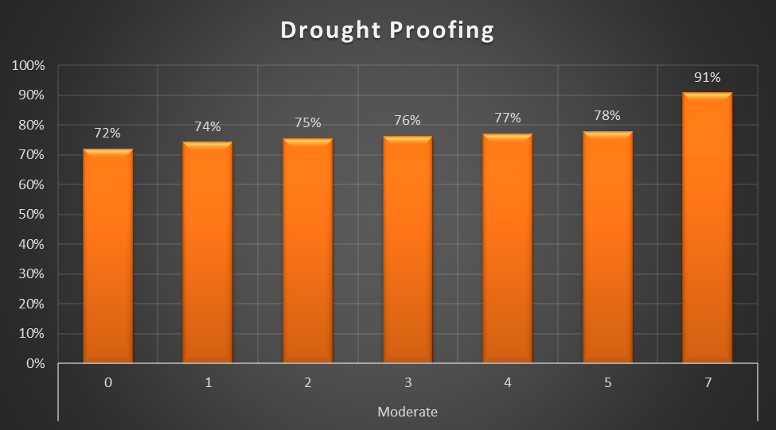

**Figure 14: Overall watershed drought proofing percentage under different scenarios for mild years**

# **Cost and benefit analysis**

Planned interventions under scenarios entail significant investments for the capital infrastructure and maintenance. Cost and benefit analysis is carried out accounting for the net cost and benefits over a horizon of 20 years with interest rate of 7 %. For more details on how this is calculated, see the [technical manual](https://drive.google.com/drive/u/1/folders/1Yi0Qt4JraRVXNljxe3DB_TAdu5VM8bhg) to see how this is calculated. Very briefly, cost and benefits are analysed assuming if we had invested in these investments 20 years ago, what would have been the overall cost and benefits considering last 20 years of rainfall. The last 20 years of observed rainfall are taken as a proxy for future weather.

Results show that to an extent cost and benefits gradually increase with the intensity of interventions. However, for all scenarios, benefit-cost ration (BCR) is above 1.5 showing benefits over 20 years will return 1.5 times the invested amount. High BCR shows for all scenarios indicate that though actual drought-proofing can only be achieved with scenario 6 or 7 but incremental benefits for all other scenarios are also beneficial. This provides the rationale for staging investment and planning over the project duration aiming to reach scenario 6 or 7.

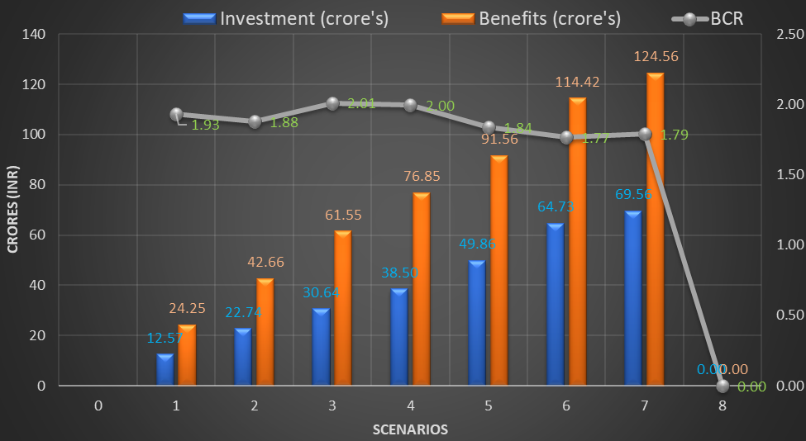

**Figure 15: Cost – benefit analysis**

# **Conclusion and recommendation**

Jhalarpatan watershed faces frequent mild and moderate drought. Over the last 15 years,10 years have been either mild or moderate drought years. Analysis of water balance and deficit shows that drought years significantly impact rabi season crops relying on irrigation. In drought years, the crop yield of rabi crops is only ~45-50 % of attainable yields. To mitigate the impact of drought, drought-proofing measures combining supply and demand interventions are planned. Simulation shows that supply (farm pond, check dams, infiltration basins) and demand (micro-irrigation, broad bed furrow) with shifting of the wheat area to low water consuming mustard crop is the best strategy to drought proof mild drought years. For moderate years, additionally, there is a need for smart irrigation budgeting. This entails limiting irrigation storage use (deficit irrigation) in kharif season so that storage can be maintained for rabi season. Results show that following this strategy, even moderate drought years can be drought proofed. Cost and benefit analysis show that all scenarios have BCR > 1.5, showing the incremental benefits under scenarios are more than the investments. Developed scenarios and results provide the rationale for staging investment and planning over the project duration.

**References**

CGWB, 2013. Groundwater information Jhalwar district, Rajasthan. Ministry of Water Resources Central Ground WaterB, Government of India. WESTERN REGION JAIPUR

Sönmez, F.Kemal., Kömüscü, A.Ü., Erkan, A., Turgu, E., 2005. An Analysis of Spatial and Temporal Dimension of Drought Vulnerability in Turkey Using the Standardized Precipitation Index. Natural Hazards 35, 243–264. <https://doi.org/10.1007/s11069-004-5704-7>

Steduto P, Hsiao TC, Fereres E, Raes D. 2012. Crop Yield Response toWater. Food and Agriculture Organization of the United Nations: Rome, Italy.

World Bank, 2019. Assessing Drought Hazard and Risk: Principles and Implementation Guidance. Washington, DC: World Bank. Link: <https://www.droughtmanagement.info/literature/WBG_Assessing_drought_hazard_and_risk.pdf>

# **Appendix A: Input data**

Table 1A: Land use details

|  |  |  |
| --- | --- | --- |
| **S.no** | **Description** | **Area (ha)** |
| **Total Agri catchment Area (ha)** | | 7663.36 |
|  | Agriculture Area (Net cultivated sown area) | 5417.74 |
|  | Fallow | 338.71 |
|  | Built-up / Settlements | 370.90 |
|  | Waterbodies | 13.00 |
|  | Pasture | 338.00 |
|  | Forest | 1185.00 |
|  | Other | 0 |

**Table 1B: Soil Data**

|  |  |  |  |  |  |
| --- | --- | --- | --- | --- | --- |
| **S.no** | **Soil Typea** | **Soil Depth (m)** | **Soil Distribution**  **(%)** | **Infiltration Rate (mm/hr)** | **Ground Water Yield of area (l/s)** |
|  | Clay Loam | 0.70 | 86 | 5-10 | 0.5-3.2 |
|  | Loam | 0.65 | 14 | 10-20 | 0.5-3.2 |

Table 1C: Cropping pattern details

|  |  |  |  |  |  |  |  |
| --- | --- | --- | --- | --- | --- | --- | --- |
| **Area** | **Crop name** | **Area Sown (ha)** | **Irrigation (ha)** | | **Crop Duration (days)** | **Crop Sowing Date** | |
| **Irrigated** | **Rainfed** | **Month** | **Week** |
| Kharif | | | | | | | |
| Area 1 | Soyabean | 3430 | 2883 | 547 | 100 | June | 4 |
| Area 2 | Maize | 831 | 664 | 167 | 120 | June | 4 |
| Area 3 | Pulses | 583 | 486 | 97 | 95 | June | 4 |
| Rabi | | | | | | | |
| Area 1 | Wheat | 1803 | 1803 | 0 | 130 | Nov | 1 |
| Area 2 | Mustard | 1287 | 1287 | 0 | 115 | Nov | 1 |
| Area 3 | Coriander | 983 | 983 | 0 | 110 | Nov | 1 |
| Summer | | | | | | | |
| Area 1 | Pulses | 8.5 | 8.5 | 0 | 95 | Mar | 4 |

aAs only 3 major crops are allowed: Groundnut area with Maize and gram area to coriander. This is done as to not to underestimate water requirements.

Table 1D: Crop details

|  |  |  |
| --- | --- | --- |
| **Crop name** | **Crop yield (tonne/ha)** | **Price (Rs/Tonne)** |
| Soyabean | 1.9 | 32000 |
| Maize | 3.45 | 19000 |
| Pulses (Black gram) | 1.48 | 44000 |
| Wheat | 4.45 | 20000 |
| Mustard | 1.97 | 34000 |
| Coriander | 1.7 | 60000 |
| Pulses (summer) | 1.43 | 40000 |

Table 1E: irrigation & domestic details

|  |  |  |  |  |
| --- | --- | --- | --- | --- |
| **Irrigation Source** | **Area (%)** | **Irrigation efficiency** | **Residual storage** | **Non-Renewable storage** |
| Irrigation | | | | |
| **Groundwater** | 95 | 0.5 | 0 | No |
| **Surface water** | 5 | 0.5 | 0 |  |
| Domestic | | | | |
| **Population** | Daily water usage (LPD) | GW dependent | SW dependent |  |
| 2810 | 60 | 90 | 10 |  |